**Transforming Education Through Clear Sound: Sennheiser’s Role in Learning**

***The new Active Learning Centre (ALC) at St Philip’s Christian College in Newcastle integrates Sennheiser’s audio technology to foster seamless communication and collaboration across dynamic learning spaces.***

**Sydney, Australia, 6 November 2024 –** The Active Learning Centre (ALC) at [St Philip’s Christian College](https://www.youtube.com/watch?v=59G-FIuscvc&ab_channel=Sennheiser) represents a significant transformation in how students engage with learning. Designed to support diverse activities, from sports and drama to group discussions and remote teaching, the ALC reflects the school’s commitment to modern, student-centered education. At the heart of this transformation is Sennheiser’s suite of audio solutions, including SpeechLine Digital Wireless (SL DW) microphones, MobileConnect, and TeamConnect Ceiling 2 (TCC 2), which enable seamless communication and elevates the educational experience.

“We wanted a facility that really enhanced the concept of active learning within our schools,” explains David Price, Director of Infrastructure Development at St Phillip’s Christian College. The challenge was to create an intuitive, technology-driven space that met the needs of both educators and students. With a history of innovation dating back to the school’s pioneering laptop program in 1999, they are comfortable being at the cutting edge of learning technology. The ALC was no different and required seamless audio integration to support diverse learning needs without overwhelming users with added complexity.

**Seamless Audio Solutions for Every Scenario**

Working with InnAVate Integrated Solutions, the school implemented several key Sennheiser technologies. The SL DW microphones deliver crystal-clear audio for classroom discussions and presentations. “The decision was made to make it as simple as possible for our teaching staff, which is why we elected to go with handheld transmitters rather than packs and lavalieres,” explains Price. These wireless solutions allow educators to focus on their students without technical distractions, reducing strain and improving well-being. “They’re not yelling throughout the classrooms – they can just talk in a normal voice.”

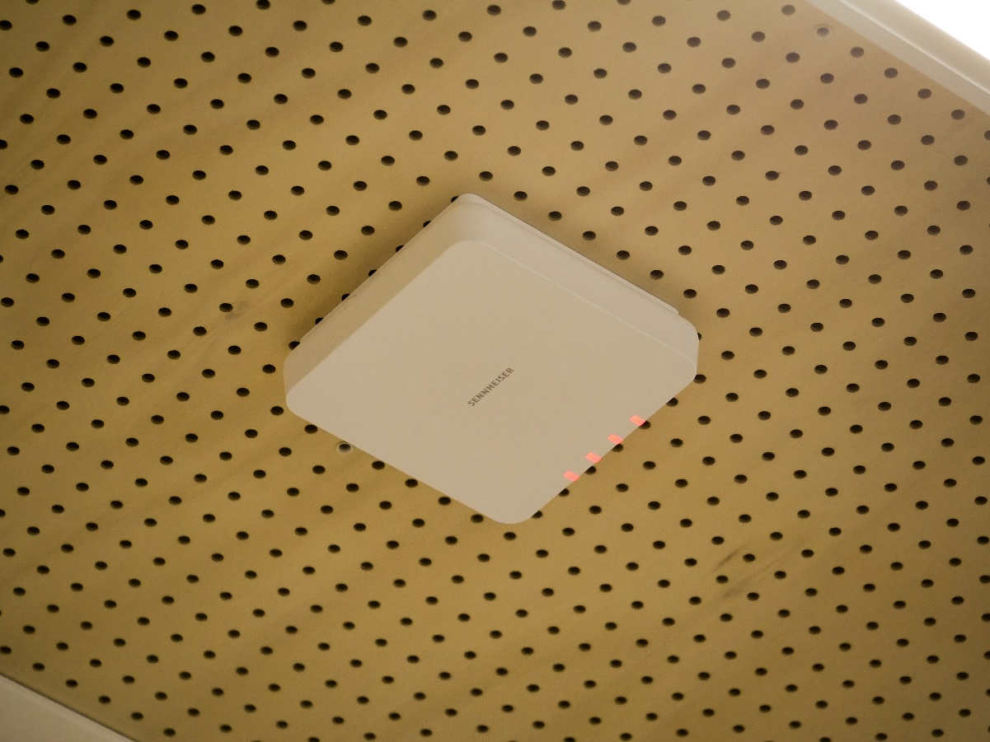

*A close up of the SpeechLine Digital Wireless at St Phillip’s Christian College*

Inclusivity was also a key consideration. The MobileConnect system offers personalised bi-directional communication, allowing students to connect through their own devices. This ensures both accessibility and hygiene, which were essential in the post-Covid environment. Anthony Finlay, Director of InnAVate Integrated Solutions, emphasises, “Having the ability to do that with personal devices rather than shared devices was the only conceptual way to keep everyone safe.”



*The MobileConnect is being tested out in a classroom*

In the school’s boardroom and tertiary classrooms, TCC 2 microphones provide seamless audio for remote collaboration. These ceiling-mounted microphones ensure intelligible speech during virtual sessions, enabling students and off-site lecturers to connect effortlessly. “Using the Sennheiser TCC 2 enables the speech within the room to be clearly heard at the other end,” explains Price. “It really brings the students and the remote lecturer into the one space cohesively.”

*The Sennheiser TCC 2 installation in St Phillips Christian College*

**Transforming Learning Through Audio**

The integration of Sennheiser technology has profoundly impacted both teaching and learning at the ALC. Teachers can now engage naturally, without worrying about projecting their voices, while students benefit from improved audio clarity. The MobileConnect system has enhanced inclusivity, offering a more focused learning experience for all.

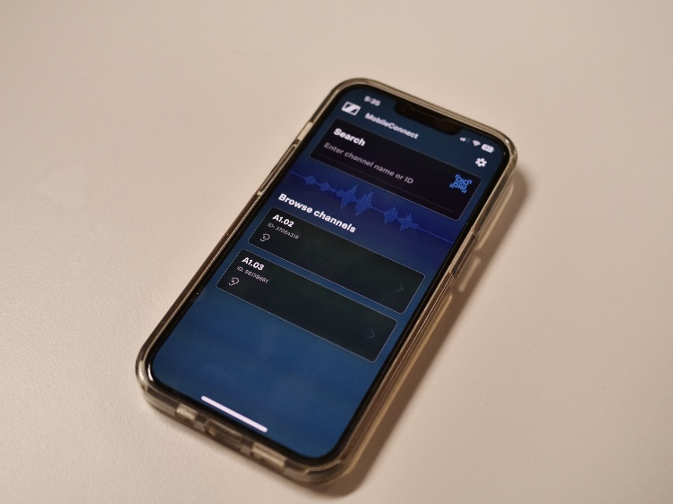

*A close up of the MobileConnect app and receiver.*

“These spaces aren’t about ‘chalk ’n’ talk,’” says Price. “We want students – particularly in Years 11 and 12 to experience adult ways of learning. This classroom format encourages critical thinking and the sharing of knowledge, preparing them for life beyond school.”

**Shaping the Future of Education with Sennheiser**

The partnership between St Philip’s Christian College and Sennheiser shows how intuitive, high-quality audio technology enhances education by fostering engagement, accessibility, and collaboration. The ALC provides students with a learning environment that reflects the modern university experience, equipping them with essential skills for the future.

More than just functioning well, Sennheiser’s solutions integrate naturally into the classroom, allowing educators to focus on student engagement. Clear, reliable audio encourages active participation and critical thinking, helping students immerse themselves in meaningful learning and collaboration.

To see more of Sennheiser’s solutions at St Phillips’s Christian College Active Learning Centre, see [**here**](https://www.sennheiser.com/en-au/stories/success-stories/st-philips-christian-college-active-learning-centre).

###

**About the Sennheiser brand**

We live and breathe audio. We are driven by the passion to create audio solutions that make a difference. Building the future of audio and bringing remarkable sound experiences to our customers – this is what the Sennheiser brand has represented for more than 75 years. While professional audio solutions such as microphones, meeting solutions, streaming technologies and monitoring systems are part of the business of Sennheiser electronic GmbH & Co. KG, the business with consumer devices such as headphones, soundbars and speech-enhanced hearables is operated by Sonova Holding AG under the license of Sennheiser.

[www.sennheiser.com](http://www.sennheiser.com/)

[www.sennheiser-hearing.com](http://www.sennheiser-hearing.com/)

|  |  |
| --- | --- |
| **Local Press Contact**  Kirsten Spruch  kirsten.spruch@sennheiser.com  +1 (860) 598-7484 | Hotwire Australia  [sennheiseranz@hotwireglobal.com](mailto:sennheiseranz@hotwireglobal.com) |